Equipment Hierarchy ODATA Documentation, 21.05.2019

Structure of OData Service:

|  |  |  |  |  |
| --- | --- | --- | --- | --- |
| **Component** | **Data Type** | **Length** | **Decimals** | **Description** |
| EQUNR | CHAR | 18 | 0 | Equipment Number |
| SERNR | CHAR | 18 | 0 | Serial Number |
| EQART | CHAR | 10 | 0 | Equipment type |
| HEQUI | CHAR | 18 | 0 | Superordinate Equipment |

Get Test Data:

Request entity with any serial number:

https://sap-fes-i.org-intra.net/sap/opu/odata/sap/Y_DIGITAL_TWIN_SRV/EquiHierarchySet?$filter=Sernr eq '4711-001'&$format=json

Regardless of the type of equipment (SSY, SYS, ENG) – the API will always return the complete hierarchy

Test Data in SAP Backend:

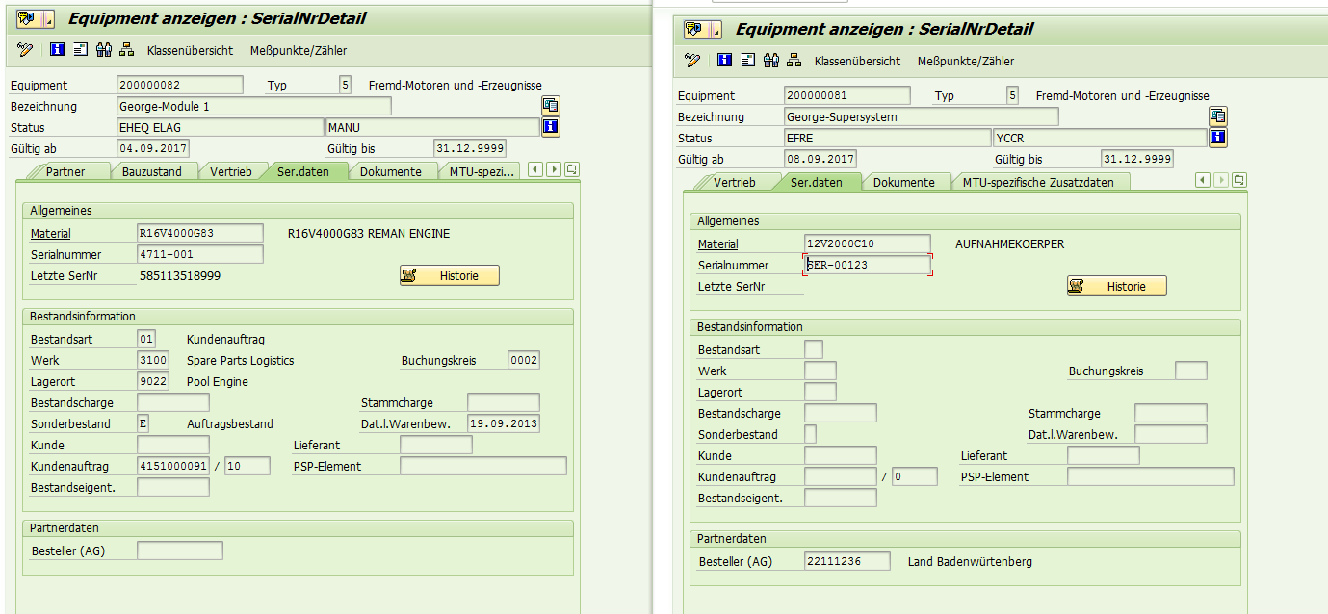

Serial number engine: 4711-001

Serial number aggregate: SER-00123

Test Data in Json:

{  
  "d" : {  
    "results" : [  
      {  
        "__metadata" : {  
          "id" : "https://sap-fes-i.org-intra.net/sap/opu/odata/sap/Y_DIGITAL_TWIN_SRV/EquiHierarchySet('000000000200000081')",  
          "uri" : "https://sap-fes-i.org-intra.net/sap/opu/odata/sap/Y_DIGITAL_TWIN_SRV/EquiHierarchySet('000000000200000081')",  
          "type" : "Y_DIGITAL_TWIN_SRV.EquiHierarchy"  
        },  
        "Equnr" : "000000000200000081",  
        "Sernr" : "SER-00123",  
        "Eqart" : "SSY",  
        "Hequi" : ""  
      },  
      {  
        "__metadata" : {  
          "id" : "https://sap-fes-i.org-intra.net/sap/opu/odata/sap/Y_DIGITAL_TWIN_SRV/EquiHierarchySet('000000000200000082')",  
          "uri" : "https://sap-fes-i.org-intra.net/sap/opu/odata/sap/Y_DIGITAL_TWIN_SRV/EquiHierarchySet('000000000200000082')",  
          "type" : "Y_DIGITAL_TWIN_SRV.EquiHierarchy"  
        },  
        "Equnr" : "000000000200000082",  
        "Sernr" : "4711-001",  
        "Eqart" : "SYS",  
        "Hequi" : "000000000200000081"  
      },  
      {  
        "__metadata" : {  
          "id" : "https://sap-fes-i.org-intra.net/sap/opu/odata/sap/Y_DIGITAL_TWIN_SRV/EquiHierarchySet('000000000200000084')",  
          "uri" : "https://sap-fes-i.org-intra.net/sap/opu/odata/sap/Y_DIGITAL_TWIN_SRV/EquiHierarchySet('000000000200000084')",  
          "type" : "Y_DIGITAL_TWIN_SRV.EquiHierarchy"  
        },  
        "Equnr" : "000000000200000084",  
        "Sernr" : "4711-002",  
        "Eqart" : "ENG",  
        "Hequi" : "000000000200000082"  
      },  
      {  
        "__metadata" : {  
          "id" : "https://sap-fes-i.org-intra.net/sap/opu/odata/sap/Y_DIGITAL_TWIN_SRV/EquiHierarchySet('000000000200000083')",  
          "uri" : "https://sap-fes-i.org-intra.net/sap/opu/odata/sap/Y_DIGITAL_TWIN_SRV/EquiHierarchySet('000000000200000083')",  
          "type" : "Y_DIGITAL_TWIN_SRV.EquiHierarchy"  
        },  
        "Equnr" : "000000000200000083",  
        "Sernr" : "4711-002",  
        "Eqart" : "SYS",  
        "Hequi" : "000000000200000081"  
      },  
      {  
        "__metadata" : {  
          "id" : "https://sap-fes-i.org-intra.net/sap/opu/odata/sap/Y_DIGITAL_TWIN_SRV/EquiHierarchySet('000000000200000085')",  
          "uri" : "https://sap-fes-i.org-intra.net/sap/opu/odata/sap/Y_DIGITAL_TWIN_SRV/EquiHierarchySet('000000000200000085')",  
          "type" : "Y_DIGITAL_TWIN_SRV.EquiHierarchy"  
        },  
        "Equnr" : "000000000200000085",  
        "Sernr" : "4711-003",  
        "Eqart" : "ENG",  
        "Hequi" : "000000000200000083"  
      },  
      {  
        "__metadata" : {  
          "id" : "https://sap-fes-i.org-intra.net/sap/opu/odata/sap/Y_DIGITAL_TWIN_SRV/EquiHierarchySet('000000000200000086')",  
          "uri" : "https://sap-fes-i.org-intra.net/sap/opu/odata/sap/Y_DIGITAL_TWIN_SRV/EquiHierarchySet('000000000200000086')",  
          "type" : "Y_DIGITAL_TWIN_SRV.EquiHierarchy"  
        },  
        "Equnr" : "000000000200000086",  
        "Sernr" : "4711-004",  
        "Eqart" : "ENG",  
        "Hequi" : "000000000200000083"  
      }  
    ]  
  }  
}